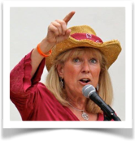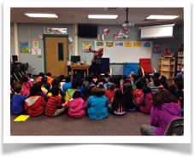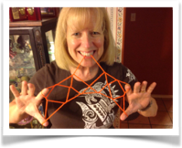

Magic happens in 3’s

**Program:**

**Where:**

**When:**

Sue Kuentz, Storyteller/Story Teacher shares:

* Folktales from around the world
* Interactive stories with music and props
* Promotes reading and writing within the tales

**<http://www.door2lore.com>**