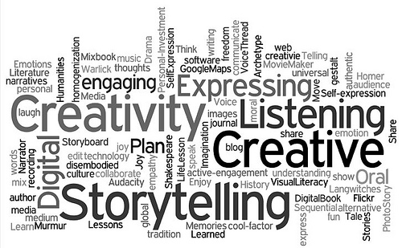

Where Oral Storytelling and Digital Technology Meet
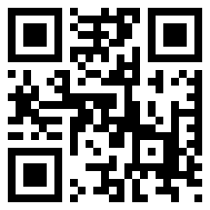
Presented by
Sue Kuentz, Librarian and Storyteller
Kuentz Creative Consulting
Sue.kuentz@gmail.com

Substantiating the Engagement of Students through Storytelling
TEKS: Reading/Comprehension of Literary Text/Theme and Genre. Here’s just a few.

Students are expected to:
*K – 12th: Identify elements of a story including setting, character and key events
*Discuss the big idea of a well-known folktale or fable and connect it to personal experience
*Identify moral lessons as themes in well-known fables, legends, myths, or stories
*paraphrase the themes and supporting details of fables, legends, myths, or stories
*summarize and explain the lesson or message of a work of fiction as its theme
*compare and contrast the themes or moral lessons of several works of fiction from various cultures
*Explain the function of recurring phrases (e.g., “Once upon a time” or “They lived happily ever after”) in traditional folk and fairy tales.
*compare and contrast the adventures or exploits of characters (e.g., the trickster) in traditional and classical literature.

Reading/Comprehension of Literary Text/Drama
*identify the elements of dialogue and use them in informal plays
*explain the elements of plot and character as presented through dialogue in scripts that are read, viewed, written, or performed.
*analyze the similarities and differences between an original text and its dramatic adaptation.

Reading/Comprehension of Literary Text/Fiction
*retell a main event from a story read
*describe the plot and retell a story’s beginning, middle, and end with attention to the sequence of events
*describe incidents that advance the story or novel, explaining how each incident gives rise to or foreshadows future events
*describe the interaction of characters including their relationships and the changes they undergo
*Sequence and summarize the plot’s main events and explain their influence on future events

Reading/Comprehension of Literary Text/Sensory Language
*identify language that creates a graphic, visual experience and appeals to the senses

Writing/Literary Texts
*write imaginative stories that build the plot to a climax and contain details about the characters and setting
*write about important personal experiences
*write a personal narrative that conveys thoughts and feelings about an experience (5th grade TEK)

Listening and Speaking/
*share information and ideas that focus on the topic under discussion, speaking clearly at an appropriate pace, using the conventions of language
*give organized presentations employing eye contact, speaking rate, volume, enunciation, natural gestures, and conventions of language to communicate ideas effectively.

Apps that Enrich the Storytelling Experience
(A few of my favorites)
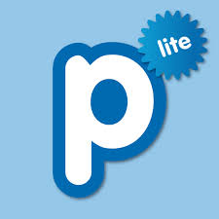
Popplet lite (fun graphic organizer for the stories)

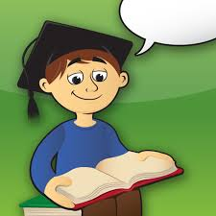
Story Wheel (Engaging app that teaches sequencing, beginning, middle, end, collaboration of students) – free with an upgrade available from the Education
Itunes AppStore. The free “Storyteller” wheel is perfect for your first year using this app. You can add “Pirates”, “Knights and Princess,”, “Space,” for $.99 each. $2.99

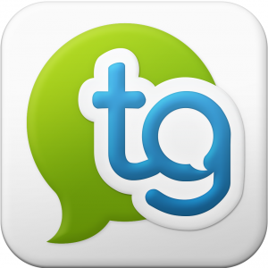
Tellagami – My new favorite storytelling app. Students can tell the beginning, or middle, or end of a story using the animated character with emotions and all. They can record their own voice or type in what they would like to be said and choose a voice on this app to read. Tellagami Edu is a paid version of the Tellagami app loaded with features that allows classrooms to use the app without in-app purchases. ($4.99) The paid version gives you 90 seconds of recording time vs. 30 sec. in the free app
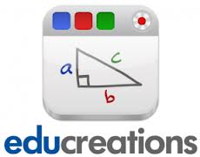
Educreations – Great for practicing your storytelling. Insert pictures from your camera or draw the main events on each page. You can then practice telling the story by recording your voice.

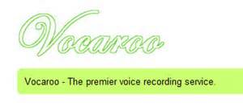
Vocaroo.com - Free voice recording service that you can attach a QR Code to – so easy for the kids! This is on computers only right now since iphone/ipad won’t allow the voice recorder. It’s important to download the recorded voice or share it soon after it’s created. The company usually cleans out the voice saves after a 1 - 2 month period. No limit on time recorded.

Interaction from the workshop group:
- I’ll tell a quick, easy to tell story that most of you know – Dark, Dark Woods. And then we’ll see which apps we could use to assist us in organizing this tale into a bare bones write up for practicing (Graphic Organizers)
- I’ll share out what some of my storytelling students created with the Story Wheel App and then it will be your turn
- If time, ask for other ideas that could be connected to our storytelling sessions in the library.

Spring Board Ideas that Librarians Can Adapt

A. Concept Stories: You just completed a biography unit with your 4th and 5th graders using all the resources available in your library. As one of several culminating activities given to them, they could apply what they have researched by writing and creating a story based on facts and then recording their story using a digital storytelling app such as Educreations

B. Multicultural unit: Students choose an artifact (3D or image) Using Vocaroo.com, students tell an “ah ha” they learned about this artifact in that culture. Kids can certainly use note cards with important info. but try to get the kids to talk into the recorder as if they were talking to their best friend – voice inflection is so important. Print out a QR code and tape it on the image or next to the artifact on display and invite others to scan and listen – You’ve created an interactive museum in your library!

C. Ancient Culture Research stations are ready to go in your library. Why not use one of those stations as a story from the past. It would be easy to set up the Tellagami App and have the students work individually or in groups to create a short, 30- 90-second story.

D. Book Club Meeting – your group just completed chapters 1 – 3 of __________________ (you fill in the title). You want the students to summarize what’s been read so far. The students could quickly use any of the apps mentioned. The best part – students use those apps to assist them when orally retelling those chapters.

Websites to visit

- Sue Kuentz’s Storytelling Website (that’s me) I’ve included a Storytelling blog where I add fresh ideas and great lesson links. Visit my blog often! Invite me as a storyteller or workshop presenter! Right now, I’m blogging every day with the Summer Reading Library Theme: Every Hero Has A Story! Great ideas. Please check them out!
www.door2lore.com

- Mitch Weiss and Martha Hamilton: http://beautyandthebeaststorytellers.com/handouts.php

- Storytelling in Education? YES! (position paper) – www.storynet.org/resources/YES%20Position%Paper.pdf

- Heather Forest’s website: http://www.storyarts.org/

- Kathy Schrock’s Guide to Everything: http://www.schrockguide.net/digital-storytelling.html

